Department of Computer Technology

Vision of the Department
To be a preferred hub for nurturing computer engineering aspirants through innovative, ethical, value-based technical education, impactful research, and industry collaboration, to become successful professionals contributing for the betterment of society.

Mission of the Department
To nurture computer engineering professionals by offering: Dynamic learning environment that encourages problem-solving using emerging technology, · National Education Policy aligned evidence-based technical education, fostering innovation, research, and industry–institute
collaboration, Holistic, ethical and sustainable development for lifelong success.

Session 2026-2027(ODD)

Vision: Dream of where you want. | Mission: Means to achieve Vision

Program Educational Objectives of the program (PEO): (broad statements that describe the professional and career accomplishments)
PEO1 | Preparation | P: Preparation | Pep-CL abbreviation
PEO2 | Core Competence | E: Environment (Learning Environment) | pronounce as Pep-si-lL easy to recall
PEO3 | Breadth | P: Professionalism
PEO4 | Professionalism | C: Core Competence
PEO5 | Learning  Environment | L: Breadth (Learning in diverse areas)

Program Outcomes (PO): (statements that describe what a student should be able to do and know by the end of a program)

Keywords of POs:
Engineering knowledge, Problem analysis, Design/development of solutions, Conduct Investigations of Complex Problems, Engineering Tool Usage, The Engineer and The World, Ethics, Individual and Collaborative Team work, Communication, Project Management and Finance, Life-Long Learning

PSO Keywords: Cutting edge technologies, Research

“I am an engineer, and I know how to apply engineering knowledge to investigate, analyse and design solutions to complex problems using tools for entire world following all ethics in a collaborative way with proper management skills throughout my life.” to contribute to the development of cutting-edge technologies and Research.

Integrity: I will adhere to the Laboratory Code of Conduct and ethics in its entirety.

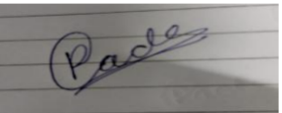
Poonam Gade / 9-08-2026

Name and Signature of Student and Date
(Signature and Date in Handwritten)

Department of Computer Technology

Vision of the Department
To be a preferred hub for nurturing computer engineering aspirants through innovative, ethical, value-based technical education, impactful research, and industry collaboration, to become successful professionals contributing for the betterment of society.

Mission of the Department
To nurture computer engineering professionals by offering: Dynamic learning environment that encourages problem-solving using emerging technology, · National Education Policy aligned evidence-based technical education, fostering innovation, research, and industry–institute
collaboration, Holistic, ethical and sustainable development for lifelong success.

Session | 2026-27 (ODD) | Course Name | LAB: Software Engineering
Semester | 7th | Course Code | 23CT1704
Roll No | 12 | Name of Student | Poonam Gade

Practical Number | 4
Course Outcome | CO1 Understand software engineering process models, incorporating requirement  engineering principles and software design fundamentals for a given project.  CO2 Apply testing principles by selecting and using appropriate testing strategies to  effectively evaluate a specific application  CO3 Use fundamental concepts of software configuration management, version  control, and change management in software development.  CO4 Analyze the cost estimation techniques and the severity of software risk for a  given application.  CO5 Evaluate the effectiveness of basic operations in Subversion (SVN) for  maintaining efficient software version control.
Aim | To study and draw the UML Use Case Diagram for the Online Voting System.
Problem Definition | An Online Voting System is a software system that allows eligible voters to register, log in, view candidate details, cast their votes, and receive voting confirmation. The Election Administrator manages voters, candidates, and election information. The system also counts votes and displays the final election results.
Theory  (100 words) | A Use Case Diagram is a UML diagram used to represent the functional requirements of a system. It shows the actors who interact with the system and the functions performed by them.  The main elements of a Use Case Diagram are actors, use cases, communication links, and system boundary. It shows what the system does from the user's point of view, rather than showing how the system works internally.  Main Elements  - Actor: A person or external system that interacts with the system.  - Use Case: A function or service provided by the system.  - Communication Link: Shows interaction between an actor and a use case.  - System Boundary: Represents the limits of the system.  Online Voting System – Use Case Diagram  Actors  There are two main actors:  - Voter  - Election Administrator  Voter Use Cases  The Voter can:  - Register  - Log In  - View Candidate List  - Cast Vote  - View Vote Confirmation  - View Election Result  All important voting activities require the voter to Log In first.  Election Administrator Use Cases  The Election Administrator can:  - Log In  - Manage Voters  - Manage Candidates  - Manage Election  - Start/Stop Election  - Count Votes  - Generate Results  - View Results
Procedure and Execution  (100 Words) | Algorithm(Steps):  - Start.  - Identify the actors of the Online Voting System.  - Identify the functions performed by each actor.  - Draw the system boundary.  - Add all required use cases inside the boundary.  - Connect actors with their respective use cases.  - Add include relationships.  - Verify the diagram.  - Save the Use Case Diagram.  - Stop.
 | Code:
Output:
The UML Use Case Diagram for the Online Voting System was successfully designed using StarUML.
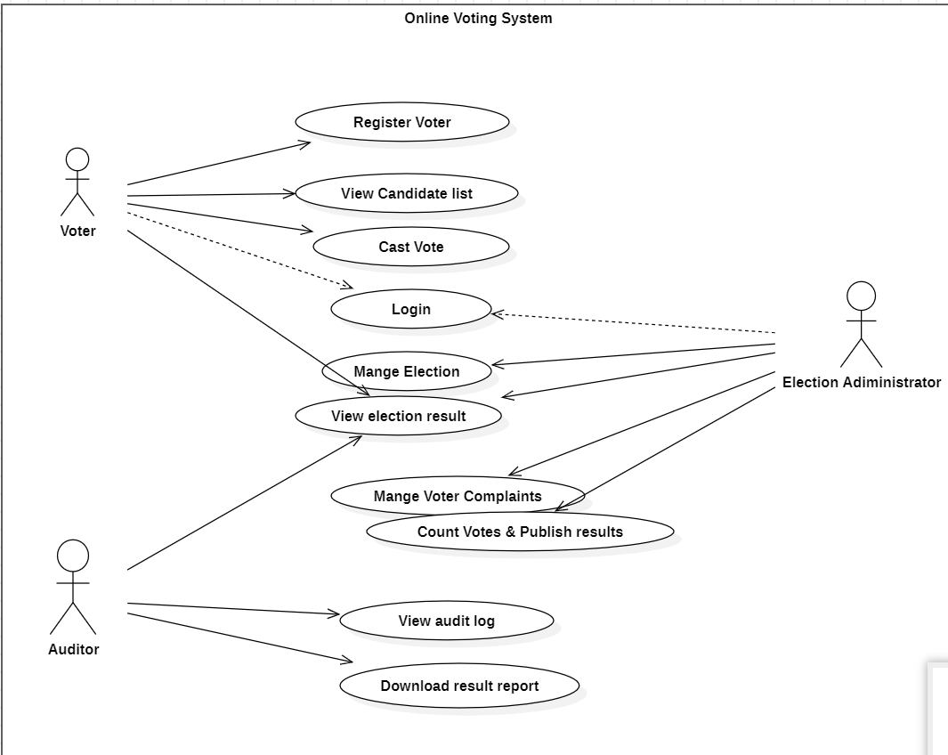
The diagram shows the interaction between the Voter, Election Administrator, and the functions provided by the Online Voting System.

Output Analysis | The Use Case Diagram clearly represents the functional requirements of the Online Voting System. The Voter can register, log in, view candidates, cast a vote and view results. The Election Administrator manages voters, candidates and election activities. The diagram also shows the required relationships between different use cases.
Link of student Github profile where lab assignment has been upload | https://github.com/23070177-cmyk
Conclusion | The UML Use Case Diagram for the Online Voting System was successfully studied and designed using StarUML. It provides a clear understanding of the actors, system functions and relationships involved in the voting process.
Plag Report (Similarity index < 12%) | 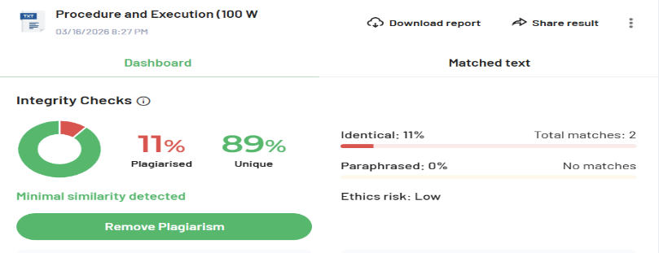
Date | 9-08-2026

